ATM + BANKING INTEGRATION SYSTEM
UML Diagrams and Backend System Design

1. Case Study Overview
Design a backend system for an ATM connected to a bank’s core banking platform. The ATM supports cash withdrawal, cash deposit, balance enquiry, and PIN change. The system authenticates the cardholder, validates each request, communicates securely with banking services, records transactions, and handles failures such as invalid PIN, insufficient funds, network timeouts, and hardware errors.

2. Main Actors and System Components
- ATM User: inserts a card, authenticates, selects an operation, and receives cash, deposit confirmation, or account information.
- ATM: captures card/PIN/input, controls cash and deposit hardware, displays messages, prints receipts, and manages the session.
- Bank Server / Core Banking: authenticates requests, checks account status and balances, posts transactions, and returns results.
- Database: stores account and transaction records; sensitive card/PIN data must be protected and PINs must never be stored in plain text.

3. Use Case Diagram
The ATM User initiates the customer-facing use cases. The Bank Server participates in authentication, account validation, and transaction processing.
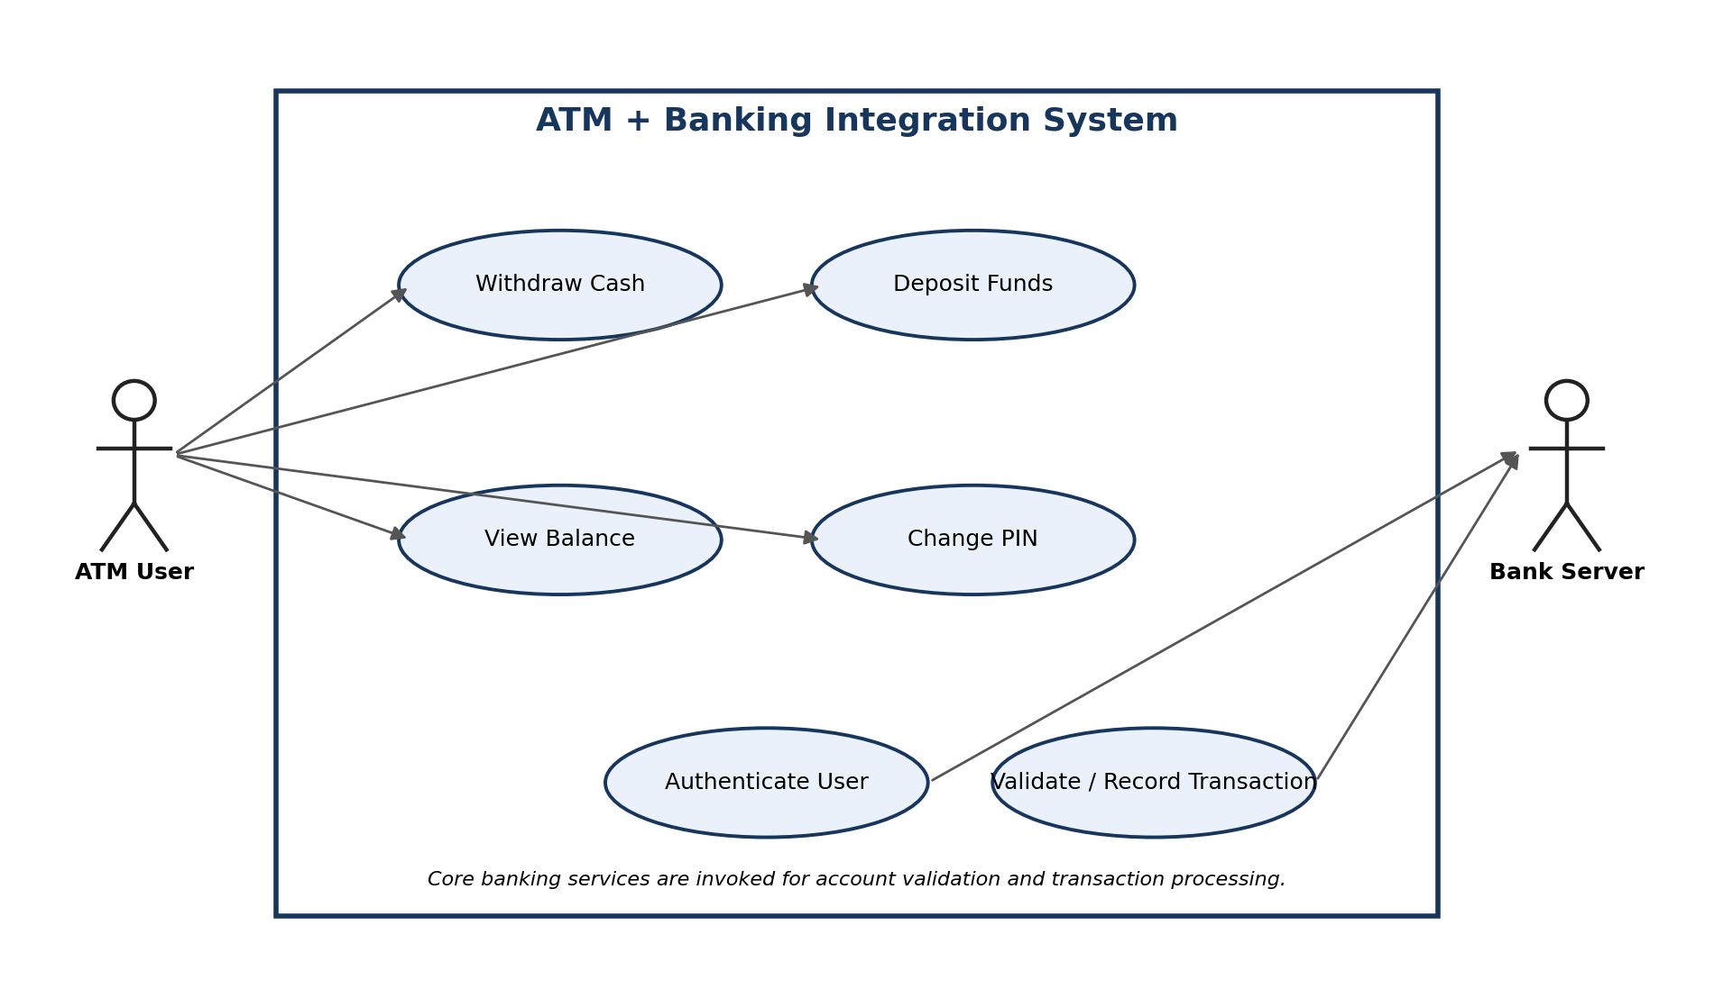

4. Class Diagram
The model separates the ATM interface, cardholder and card details, account data, transaction lifecycle, and the remote banking server.
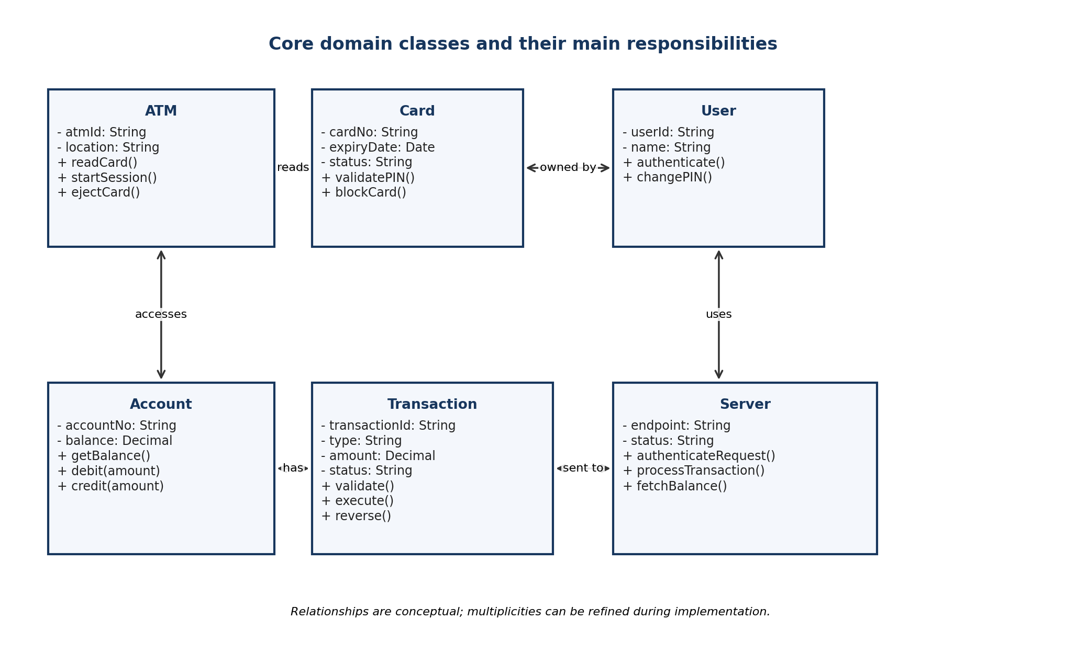

5. Sequence Diagram — Withdraw Cash with Balance Check
The withdrawal is approved only after authentication and a server-side balance check. The ATM dispenses cash only after the bank confirms the debit/authorization.
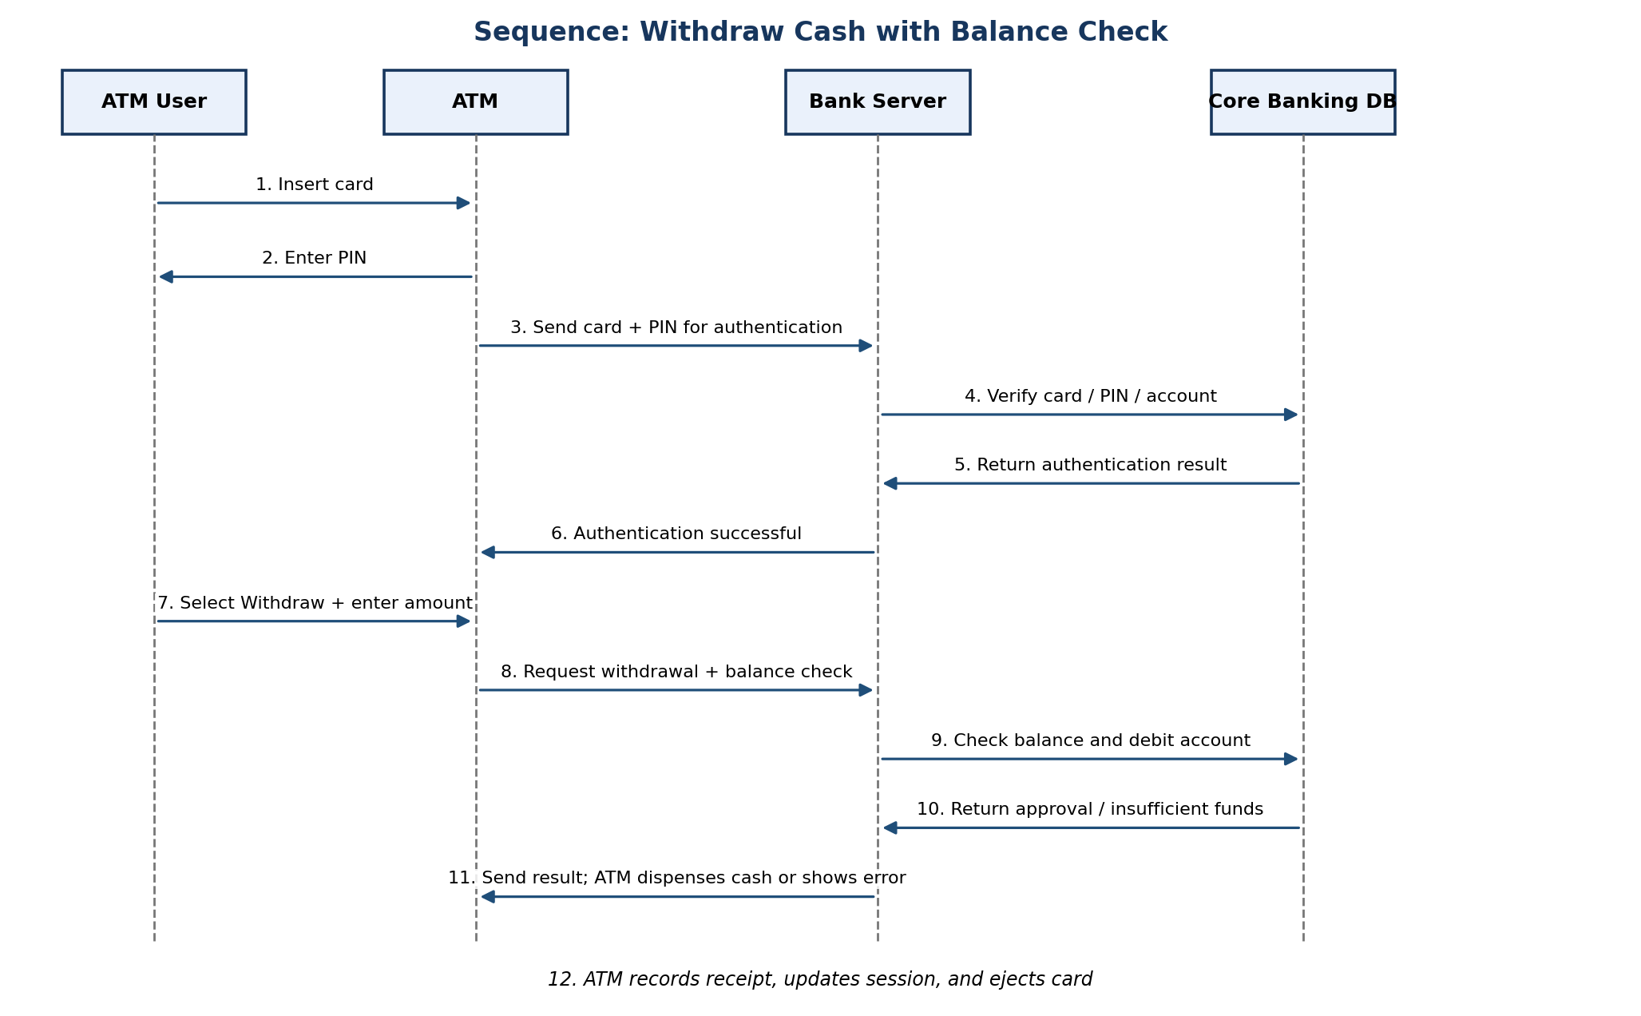

6. Activity Diagram — Complete ATM Operation
This flow covers card reading, PIN authentication, operation selection, bank-side validation, transaction posting, customer feedback, and card ejection. Error paths safely stop or allow a retry.
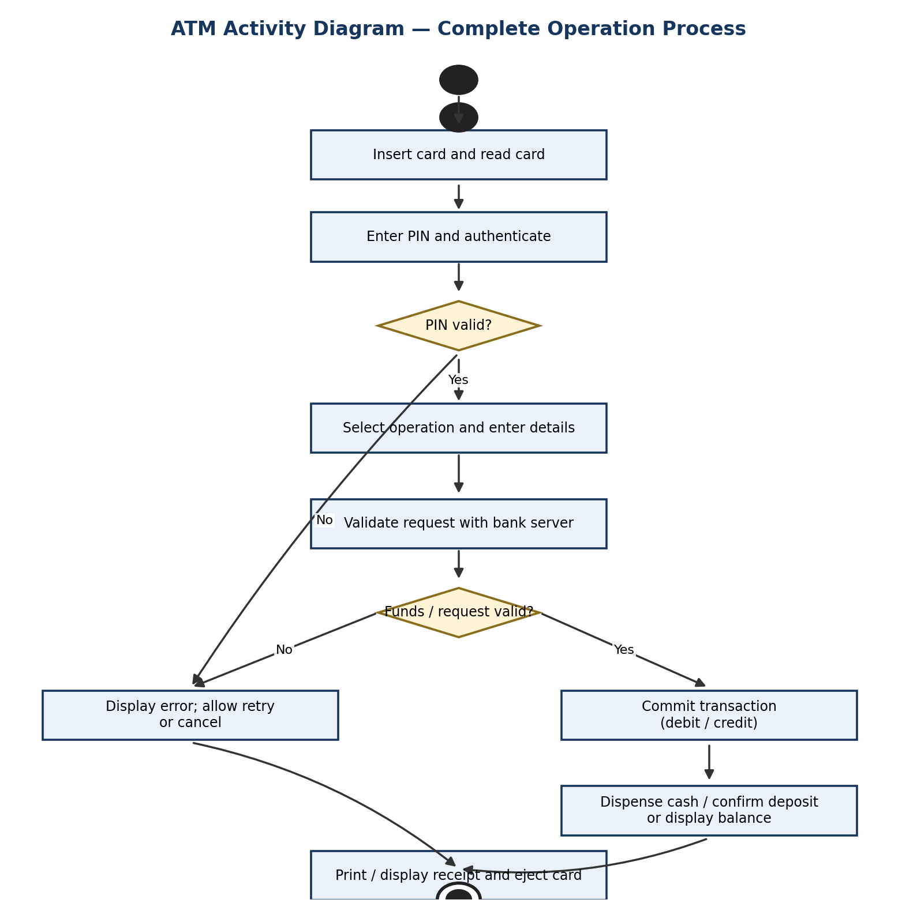

7. State Machine Diagram
The primary ATM session states follow the required progression: Idle → Card Inserted → Authenticated → Transaction → Eject Card. Invalid PINs, cancellation, and server failures are handled as guarded exception paths.
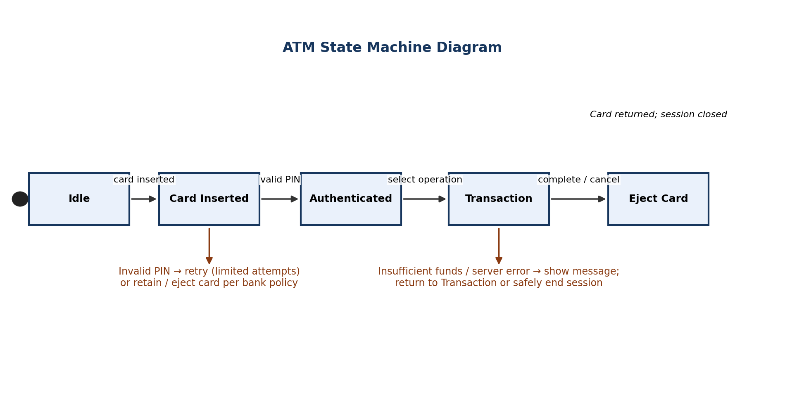

8. Backend Processing and Error Handling
- Authentication: validate card status and PIN through a secure banking interface; apply retry limits and card-blocking policy.
- Withdrawal: verify account status and available balance, authorize/debit atomically, then command the cash dispenser. Reconcile if cash dispensing fails after authorization.
- Deposit: accept and count notes, create a deposit transaction, and follow bank rules for immediate or delayed availability.
- Balance enquiry: request the latest available balance from core banking and display only the permitted account information.
- PIN change: verify the current credential and securely update the PIN through an approved PIN-management service.
- Reliability: use unique transaction IDs, idempotency keys, timeouts, retry rules, audit logs, and reversal/reconciliation procedures to prevent duplicate or lost transactions.
- Security: encrypt communications, use mutual authentication between ATM and bank services, protect secrets in hardware security modules where applicable, mask account data, and maintain tamper-resistant audit trails.

9. Assumptions
The diagrams are logical UML-style design views. Exact APIs, message formats, database schema, cash dispenser protocols, deposit clearing rules, and card-retention policy depend on the bank, ATM vendor, and applicable payment-network standards.

